Follow below steps to use the attached script:-

1. Select all the test cases you want to execute and open Manual Runner.

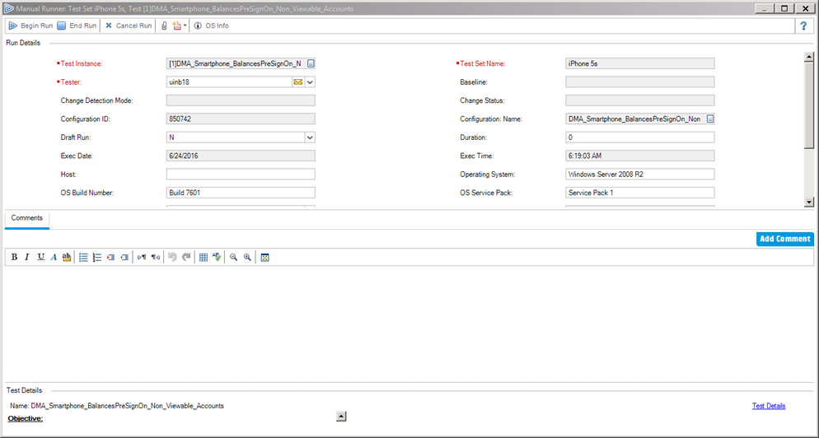

1. Now Open the file which I have given, it will ask for “How many test cases you want to execute?”, enter the appropriate number and press ‘OK’.

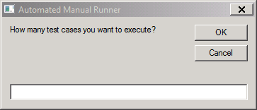

1. Then immediately switch to Manual Runner (I have given 5 sec delay, before script starts executing). After that script will Execute and Pass the number of test cases which you have mentioned in Step 2.
2. Once the script execution is completed, it will display “Success” Message. (**Note:** Do not switch to any other window while script is running)

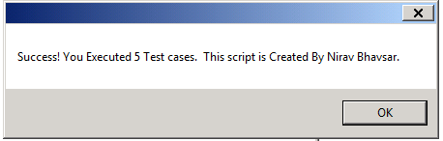

**Tip:-** To Automatically fill Application Name/Project Name/Release in Test Run on all the test cases which you have executed.

1. Apply appropriate filter, so that only test cases for which you want to set Application Name/Project Name/Release is visible.
2. Click on Edit --> Replace..
3. Set Appropriate Value in *Find Value* Field
4. Keep *Value to Find* Field Blank
5. Set Appropriate Value in *Replace with* Filed
6. Click *Replace All*

